CEDARWOOD SYSTEM FUNCTIONAL SPECIFICATION

Revision history

| Revision Date | Summary of Changes | Version No. | Author |
| --- | --- | --- | --- |
| 28 July 2015 | Initial Draft | Version 1 Draft 1 | Maria Lotsman |
| 04 August 2015 | Review, added Jay comments | Version 1 Draft 2 | Maria Lotsman |
| 11 August 2015 | Added IDs, and revision history | Version 1 Draft 3 | Maria Lotsman |

# Document structure

The document provides information about Library view for the Cedarwood application. The document called Functional package – has the description of the library functionality. Business rules & behavior rules marked as LBR_###, meaning that this is a requirement for Library functionality and number.

# Functional package: Library

Library provides a feature to manage the documents stored within the system. There are such functions provided within the library for user:

* Search through the documents
* Documents management such as
  + Download of the documents
  + Upload of the documents
  + Delete /Undo delete
  + Recreate a document from archive

## UI Common behavior

Please, see below the wireframe for [Library view](http://8jg8d7.axshare.com/#p=cedarwood_library_view&c=1):

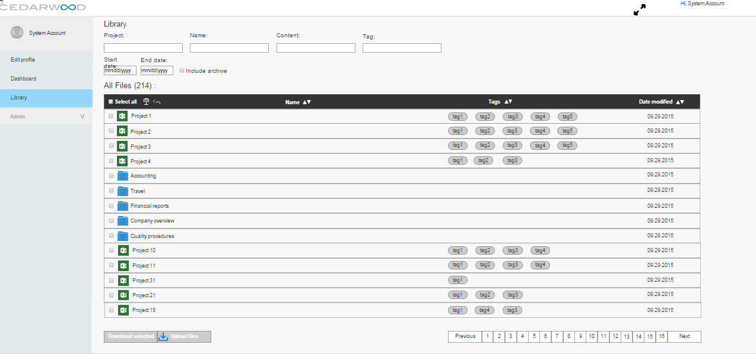

Please, see the screenshot of the library with numbered controls & fields. Description of the controls and fields can be found below in the table:

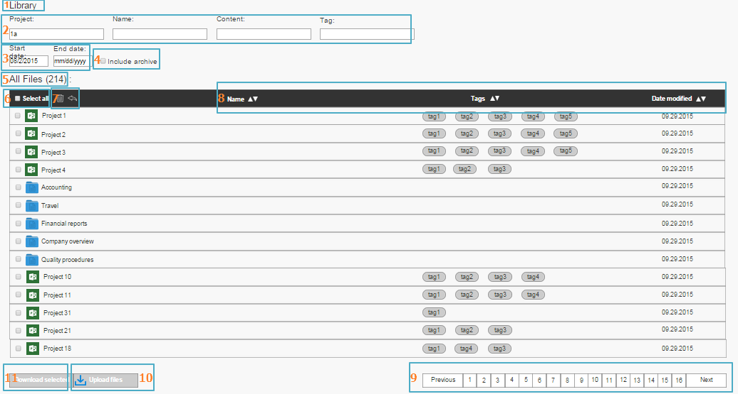

Description of the first Library screen:

**Table 1. UI description for Library main screen**

|  |  |  |  |  |
| --- | --- | --- | --- | --- |
| **Ref #** | **Name of the field**  **(label)** | **Type of control** | **Description** | **UI screenshot** |
| LBR_ | Library | Label | Name of the page on which user is |  |
| 2 | Project,  Name,  Content,  Tag | Text field with label | Search field for user;  There are 4 search fields. |  |
| 3 | Start date;  End date | Calendar  Control (text field with date) | Calendar, where user can pick up the date. | Closed state    Open state |
| 4 | Include archive | Checkbox | User can search within archived files when checked. |  |
| 5 | All files | String | Amount of all files available for user |  |
| 6 | Select all | Checkbox | User can select all files in one time/ unselect all files in one time. |  |
| 7 | - | Icon trash;  Icon undo; | User can delete /archive files by click on the trash icon. By clicking on the arrow – the action of delete is undone. |  |
| 8 | Name;  Tag;  Date modified; | Filter | User can filter through the Name (in alphabetic order and other way); by tag (same as above), by date (from earliest/from latest) |  |
| 9 | Previous;  Numbers  Next; | Pages selection | User can go through the results of the search if the exceed 1 page view; |  |
| 10 | Upload | Button with icon | User can select to upload the files; |  |
| 11 | Download | Button with icon (icon TBA) | User can select to download the files. Files are downloaded in the one directory that is set for browser. |  |

## Search

As a part of the long-term automation strategy, the content of any uploaded documents will be extracted and put into ElasticSearch to provide full-text searching. Along with the content, any relevant meta-data such as file type, size, author, etc. will be extracted and put into a set of pre-defined properties to be used in search and analysis.

The ultimate goal is to be able to categorize and tag documents automatically as well as find all proper names within documents for matching and to uncover additional analysis requirements.

In addition to indexing for search, the system will also attempt to classify the document as “legal”, “financial”, etc. based upon the content and extract relevant counterparties. The first approach to classification will be based on word count, a prototype of which is being developed in Access. For counterparty identification, the system will extract the proper nouns from the content to assist the user in building the relationships within the fund. Both of these approaches will be refined over time using available machine learning algorithms and technology.

User shall be able to search documents by

* Name
* Project
* Content
* Tag

Search can be adjusted with:

* Date: a specific date or a start & end date
* Archive: can be included or no

### Search: business rules

|  |  |  |  |
| --- | --- | --- | --- |
| **#** | **Business rule description** | **Field Validation rule** | **UI connected** |
| LBR_001 | User can search through the 4 available fields: project, name, tag, content. | String; Text format (no png,jpeg etc) | **Table 1. UI description for Library main screen**  Ref#2  See UI link to  [Cedarwood_library view](http://8jg8d7.axshare.com/#p=cedarwood_library_view) |
| LBR_002 | Search starts with 0.5 sec after user types in 3 characters in any field. Search need to be according to the specified field or fields if more than 1 specified by user. |
| LBR_003 | Search is done in close to real-time (0.5 sec wait). Meaning, when user makes any changes to the search fields filtering is applied with a new condition that is available is search field(s), data, or archive. |
| LBR_004 | User can specify the date for the search.  Date can be specified as a specific date (i.e. 08.08.1988) or it can be specified as a date range (i.e. 08.08.1988 – 08.20.1988) | Date format depending on which set up within user system | **Table 1. UI description for Library main screen**  Ref#3 |
| LBR_005 | User can specify to search within the archive files also. The search results need to include the archived files then. | Checkbox with two states: checked and non-checked | **Table 1. UI description for Library main screen**  Ref#4 |
| LBR_006 | If user search results provide files which were archived, user can recreate the file from the archive. | - | See link to UI  [Search within archive](http://8jg8d7.axshare.com/#p=search_within_archive) |
| LBR_007 | Result of the search are presented as a list with all projects being opened, all folders being opened. |  | See link to UI  [Search by tag within all library](http://8jg8d7.axshare.com/#p=search_by__tag5__within_all_library) |
| LBR_008 | Project and Folders are always on 1st level of hierarchy. |  | See link to UI  [Search by tag within all library](http://8jg8d7.axshare.com/#p=search_by__tag5__within_all_library) |
| LBR_009 | Project can not contain a folder within itself. Same for folder, folder can not contain a project within itself. |  | See link to UI  [Search by tag within all library](http://8jg8d7.axshare.com/#p=search_by__tag5__within_all_library) |
| LBR_010 | Folder can have only documents within. Project can only contain documents within them. |  | See link to UI  [Library with folder open](http://8jg8d7.axshare.com/#p=library_with_folder_open_folder_quality_proceedure)  [Library with Project 1 open](http://8jg8d7.axshare.com/#p=library_with_project_1_open) |
| LBR_011 | Folder and Project can be opened in one time. |  | See link to UI  [Library with Project 1 and folder open(Quality proceedures)](http://8jg8d7.axshare.com/#p=library_with_project_1_and_folder_open_quality_pro) |
| LBR_012 | Files can be all selected at one by user. When selected one Project or one folder, all files that belong to that entity are selected. |  | See UI link  [Library with folder open](http://8jg8d7.axshare.com/#p=library_with_folder_open_folder_quality_proceedure)  [Library with Project 1 open](http://8jg8d7.axshare.com/#p=library_with_project_1_open)  And select Project 1 and Folder. |

# Document management within Library

Within the library user can download documents, upload them and recreate those from archive files (if needed).

## Upload

The upload functionality is how documents get into the system. Uploading can be done by any user of the system, but there is a slightly different flow for clients. For clients, we know who the document is for by virtue of the fact that clients can only upload documents for themselves. When a client uploads a document, they need to choose the project (aka Fund) for which they are uploading the document and can select the document type to keep track of which required documents have been provided.

After uploading, the document will go to an inbox-like holding area, it will be marked as needing review, and a notification will be sent to whoever is managing the project. This helps to keep the system organized without requiring clients to fully understand how documents are processed by Cedarwood. After review where the document is categorized, tagged, and assigned for processing it is moved to the appropriate folder within S3.

For Cedarwood users, when uploading a document the categorization, tagging, and assignment can be performed at upload time which allows us to skip the holding/review cycle and transfer it to the appropriate S3 folder directly.

There will be a screen which shows all documents uploaded within a given time period as well as an easy way to see which documents are awaiting review/classification.

Please, see suggested activity diagrams:

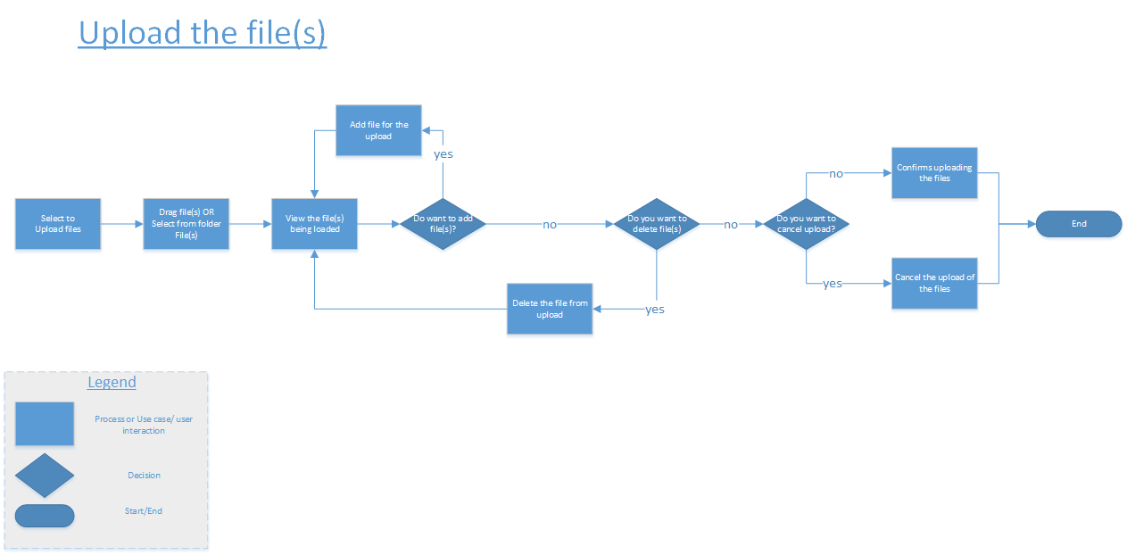

## Download

The download functionality is made up of 3 separate functions:

* Single file download where a user clicks on a document link and can download the document directly.
* Package download where the user can select multiple documents and can download a ZIP file which contains the selected files.
* Report delivery, where a client can download the generated report files.

## Business rules for the document management

Please, see below the business rules for Upload/download functionality.

|  |  |
| --- | --- |
| **ID** | **Business rule description** |
| LBR_013 | Single document can be downloaded via link. |
| LBR_014 | Multiple files can be downloaded. |
| LBR_015 | Report about that client have downloaded all necessary files can be generated and downloaded |
| LBR_016 | User can upload single file or multiple files (folder). When user uploads folder, all the files are represented as a list of files (not a folder) |
| LBR_017 | Summary file size limitation is XXX MB. Single file limit is XXX MB |